|  |
| --- |
| EPAM Systems, RD Dep. |
| MTN.BI.08 PL/SQL Techniques |

|  |  |  |  |  |  |
| --- | --- | --- | --- | --- | --- |
| REVISION HISTORY | | | | | |
| Ver. | Description of Change | Author | Date | Approved | |
| Name | Effective Date |
| 1.0 | Initial status | [Kiryl Bucha](mailto:Kiryl_Bucha@epam.com) | 12-JAN-2012 |  |  |
| 2.0 | Updated in accordance with renewed content | [Elias Nema](mailto:Elias_Nema@epam.com) | 20-JAN-2014 |  |  |
| 3.0 | Report | Aksana Kuratnik | 07-DEC-2017 |  |  |

Contents

1. Create Packages for Reload Dimension from DW to SAL 3

2. Test Your Data 3

3. Task Results 3

# Create packages to load dimensions from ST (staging) to SL (star layer)

The Main Task is to create independent packages to reload dimensions according to your DWH solution concept that was developed on Module 6 Introduction to DWH.

Required points:

* Create all required dim objects on SL Layer
* Grant all required privileges to SL_CL (Cleansing Layer)
* Create packages to load dim data (one package = one dimension) on SL_CL
* Use Bulk Collect (One or more procedures)
* Use Forall (One or more procedures)
* Use a cursor FOR loop
* Use EXECUTE IMMEDIATE INTO for dynamic queries
* Use cursor variables
* All required tables were created. The scripts are in the project folder.
* 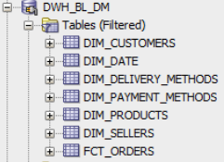
* STAR Shema:
* 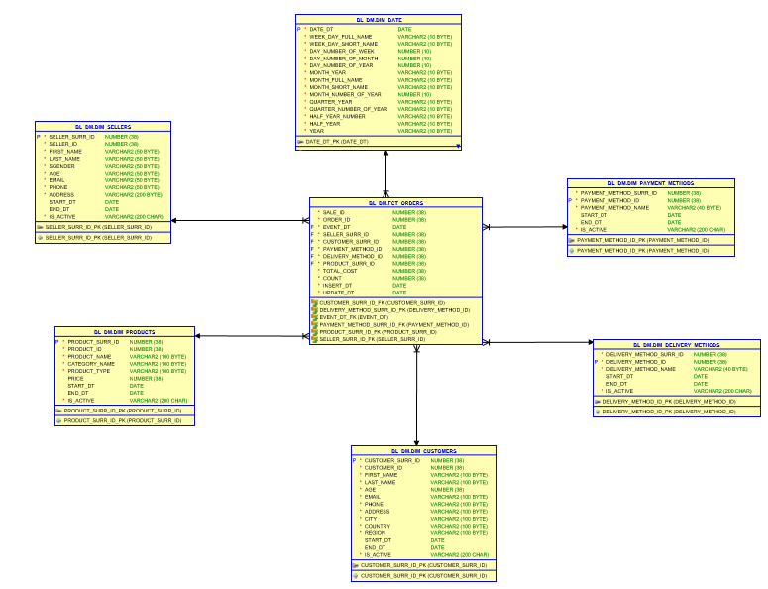

Table on 2ND BL_CL layer were created and data was load:

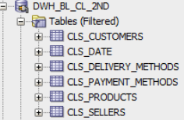

Package to insert data from bl_cl_2nd to bl_dm

CREATE OR REPLACE PACKAGE pkg_etl_insert_payment_methods

AUTHID CURRENT_USER

AS

PROCEDURE merge_dim_payment_methods;

END pkg_etl_insert_payment_methods;

/

CREATE OR REPLACE PACKAGE BODY pkg_etl_insert_payment_methods

AS

PROCEDURE merge_dimpayment_methods

IS

BEGIN

MERGE INTO bl_dm.dim_payment_methods_scd t USING

( SELECT payment_method_surr_id,

payment_method_desc,

start_dt,

end_dt,

is_active

FROM cls_payment_methods_scd

MINUS

SELECT payment_method_id,

payment_method_desc,

start_dt,

end_dt,

is_active

FROM bl_dm.dim_payment_methods_scd

) c ON ( t.payment_method_desc = c.payment_method_desc

AND t.start_dt = c.start_dt)

WHEN matched THEN

UPDATE SET

t.payment_method_id = c.payment_method_surr_id,

t.end_dt = c.end_dt,

t.is_active = c.is_active

WHEN NOT matched THEN

INSERT

(

payment_method_surr_id,

payment_method_id,

payment_method_desc,

start_dt,

end_dt,

is_active

)

VALUES

(

bl_dm.dim_payment_methods_seq.NEXTVAL,

c.payment_method_surr_id,

c.payment_method_desc,

c.start_dt,

c.end_dt,

c.is_active

) ;

COMMIT;

EXCEPTION

WHEN OTHERS THEN

RAISE;

END merge_dim_payment_methods;

END pkg_etl_insert_payment_methods;

/

